ELECTROMAGNETIC WAVES

* Electromagnetic radiations are composed of electromagnetic waves that are produced when an electric field comes in contact with the magnetic field. It can also be said that electromagnetic waves are the composition of oscillating electric and magnetic fields.
* It consists of time-varying electric and magnetic fields which are perpendicular to each other and are also perpendicular to the direction of [propagation of waves](https://byjus.com/physics/waves/). Electromagnetic waves are transverse in nature. The highest point of the wave is known as the crest while the lowest point is known as a trough. In vacuum, the waves travel at a constant velocity of 3 x 108 m.s-1.

A plane Electromagnetic wave travelling in the x-direction is of the form-

$$E\left(x,t\right)=Emax cos⁡(kx-ωt+∅)$$

$$B\left(x,t\right)=Bmax cos⁡(kx-ωt+∅)$$

$where E is the electric field vector and B is the magnetic field vector.$

* 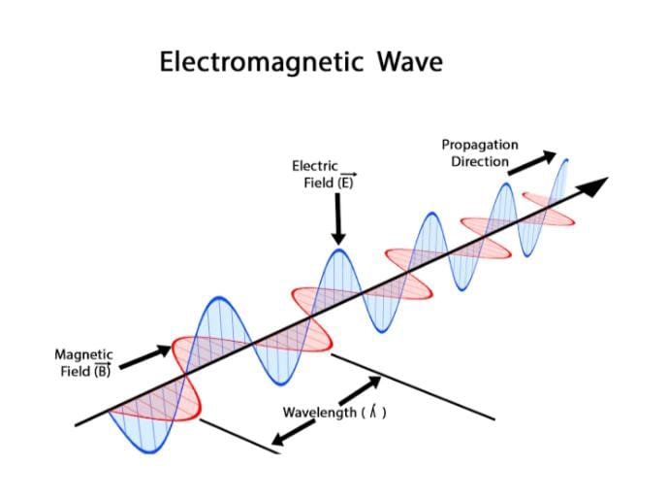

ELECTROMAGNETIC SPECTRUM-

* The electromagnetic (EM) [spectrum](https://imagine.gsfc.nasa.gov/resources/dict_qz.html#spectrum) is the range of all types of EM [radiation](https://imagine.gsfc.nasa.gov/resources/dict_qz.html#radiation). Radiation is energy that travels and spreads out as it goes.
* It is the full range of electromagnetic radiation, organized by frequency or wavelength. The spectrum is divided into separate bands, with different names for the electromagnetic waves within each band.
* 